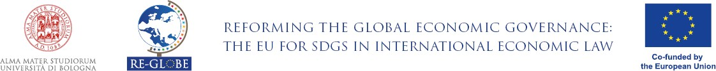
Please, send the questionnaire answered and signed to klarissa.martins2@unibo.it

Seminar Looking for Sustainability in Global Economy: The New Generations of EU Free Trade Agreements
14 December 2022, 11am Rome Time Sala delle Feste, Palazzo Malvezzi, Via Zamboni 22

Name:……………………………………………email:…………………………………….
Institution:……………………………………………………………………………………

- How did you know about the event?

………………………………………………………………………………….…….……..

- Do you have an International Economic Law background?

………………………………………………………………………………………….

- Which topic(s) did you consider most relevant when deciding to attend the event?
…………………………………………………………………………………………

- Which topic(s) did you most appreciate during the event?

.……….……………………………………………………………………………………

- Which topic(s) did you least appreciate during the event?

……………………………………………………………………………………….…

- Did you miss the discussion of a special topic? If yes, which one(s)?

…………………………………………………………………………………………………..………………………………………………………………………………………….

- Commentaries and suggestions:
…………………………………………………………………………………….……………………………………………………………………………………………….………………………………………………………………………………………….

